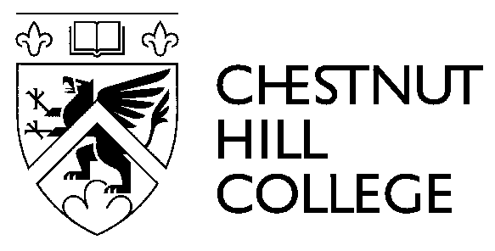
NEWS FROM THE OFFICE OF PUBLIC RELATIONS

September 8, 2015

FOR IMMEDIATE RELEASE CONTACT: Cristina Diaz
Media and Community Relations Manager
215.753.3684

Chestnut Hill College Prepares for World Meeting of Families

Philadelphia, PA- In preparation of Pope Francis’ visit to Philadelphia for the World Meeting of Families, Chestnut Hill College will be marking this historic and spiritual event through numerous celebrations. The College’s annual Mission and Legacy week will provide opportunities for the College community and the public to engage in the event.

Chestnut Hill College Events Open to the Public in Celebration of Pope Francis’ visit to Philadelphia

- Sept. 10, Campaign for Mercy and Justice: The College will begin its involvement in the Campaign for Mercy and Justice’s advocacy and public witness projects through a letter writing campaign to Congress advocating for an end to poverty in keeping with Pope Francis’ call to mercy and justice. The College will also be participating in the Mary Undoer of Knots public art project, a special effort in honor of the pope’s favorite devotion to Mary by signifying the burdens each person carries on strips of fabric tied into lattices in a downtown art display.

- Sept. 16, 4 p.m., Gruber Theater, Brother Mickey McGrath, OSF “The Message of Pope Francis”: This lecture and multimedia presentation, including Brother Mickey’s art, will offer a chance to reflect on the pontiff’s message of Hope and Joy, with a special focus on Pope Francis’ call to young people.

- Sept. 29, 2 p.m., East Parlor, “Doing the Laundry and Dirty Shoes: Leadership Lessons from Pope Francis,” Chris Lowney: Chris Lowney, renowned author of the book, “Pope Francis: Why He Leads the Way He Leads, Lessons from the First Jesuit Pope,” will present a lecture titled, “Doing the Laundry and Dirty Shoes: Leadership Lessons from Pope Francis.”
- Sept. 30, 2 p.m., East Parlor, “Reflecting on the SSJ Charism and Mission” Katherine Hanley, CSJ: The College will celebrate Founders’ Day, a commemoration of Chestnut Hill College’s founding in 1924 by the Sisters of St. Joseph, with a talk given by Katherine Hanley, CSJ titled, “Reflecting on the SSJ Charism and Mission.” This talk will explore the connection between the mission of the Sisters of Saint Joseph, the message being preached by Pope Francis and the call today to live a mission of active, inclusive love.

For more information about these events please contact Joannie Cassidy, SSJ, M.A., director of campus ministry at 215.248.7095 or cassidyj@chc.edu. For more information regarding the lectures offered by Brother Mickey McGrath, OSFS, or Chris Lowney, please contact Susanne Harkins, assistant to the dean of the school of undergraduate studies at 215.248.7019 or harkinss@chc.edu.

###

About Chestnut Hill College

Celebrating 90 years of tradition and risk, Chestnut Hill College is a four-year coed Catholic college in the Ignatian tradition that offers a traditional liberal arts undergraduate program as well as accelerated undergraduate degrees, master’s and doctoral programs. The College has been rated by US News & World Report as among the best master’s universities in the North, as among the best Northeastern colleges by The Princeton Review, and has been classified as selective by The Carnegie Foundation for the Advancement of Teaching. Since 1924, the College has offered a rigorous curriculum that provides students with a broad background in the humanities, social sciences, and natural sciences. The goal of Chestnut Hill College has been to prepare students for life’s challenges by helping them to grow intellectually, spiritually, emotionally, and socially.

