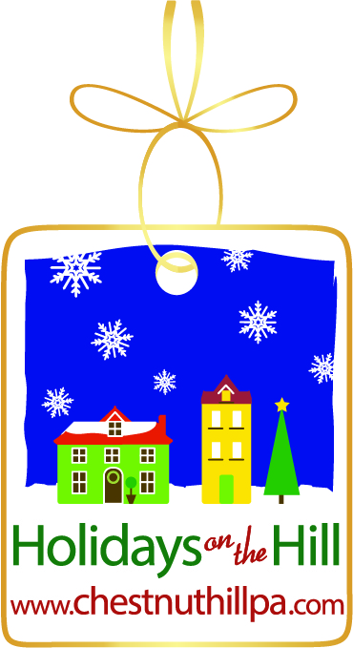

FOR IMMEDIATE RELEASE Contact: Katie English
October XX, 2014 267-974-1250

Chestnut Hill Announces Annual
“Holidays on the Hill” Festival

Philadelphia, Pa – October XX, 2014. The Chestnut Hill Business District announced its schedule for the annual, month-long festival to celebrate the holiday season today. “Holidays on the Hill” will officially commence on Saturday, November 22nd with the annual Circle of Trees lighting event at Woodmere Art Museum and continue through Christmas with holiday cheer and shopping, food and spirits, Santa and music. Throughout the season, Chestnut Hill Cares will host its annual book and toy drive for children.

“It’s beginning to look a lot like Christmas in Chestnut Hill! Our annual ‘Holidays on the Hill’ celebration is a beloved tradition in Philadelphia’s Garden District and we are excited to host residents and visitors for merriment throughout the season,” said Martha B. Sharkey, Executive Director of the Chestnut Hill Business District. “We are especially proud of the Chestnut Hill Cares: Give a Toy, Share a Book—Feel the Joy. Spread the spirit this season and donate a new, unwrapped toy or book to a child. Drop-off spots will be located in local businesses throughout the neighborhood.”

Circle of Trees on November 22nd is an honored tradition as family and friends come together to celebrate the annual tree lighting and the beginning of the holiday season with Santa. Woodmere Art Museum celebrates “A Christmas Past in the Pennsylvania German Tradition” with a new exhibit opening on Saturday, November 15th. On Saturday, November 29th, Morris Arboretum’s Holiday Garden Railway will hold its Grand Opening at 1:00 p.m.

Stag and Doe Nights, Chestnut Hill’s oldest and favorite tradition with stores open ‘til 9:00 pm on Wednesdays with music, carolers, refreshments, roasted chestnuts and Santa, will occur on December 3rd, December 10th, and December 17th. On Saturday, December 13th and Sunday, December 14th Market at the Fareway will host an outdoor Mobile Glass Blowing Studio showcasing glass blowing and ornament making on the Avenue. Saturday, December 6th is the annual Chestnut Hill Holiday House Tour, during which guests get a sneak peek into some of Chestnut Hill’s architectural gems. Elves will be on the Avenue Saturday, December 6th, Sunday, December 7th, Saturday, December 20th and Sunday, December 21st. For more information including a full schedule of “Holidays on the Hill” events please visit www.chestnuthillpa.com/chestnut-hills/holiday-festival.

Chestnut Hill is a shopping destination, especially during the holiday season. In addition to the over 60 shops in the neighborhood, Chestnut Hill will host the Ultimate Pop-Up Shop at 8514 Germantown Ave. beginning on November 7th. Several shops will participate, including the Pennsylvanian Horticultural Society (PHS) which is holding its Holiday Pop-Up Shop in Chestnut Hill for the third season. Other shops include Hillsley Hood and From Bali to Bala.

-more-

Chestnut Hill Announces “Holidays on the Hill”
Page 2

Many thanks to Holidays on the Hill sponsors and supporters including Elfant Wissahickon Realtors, Gravers Lane Gallery, The Goldenberg Group, Mike Hickey Insurance Agency, Chestnut Hill Hotel, Woodmere Art Museum, and Morris Arboretum as well as the Chestnut Hill book and toy drive sponsors, Chestnut Hill Hospital and Valley Green Bank.

About the Chestnut Hill Business District
The Chestnut Hill Business Association (CHBA) is a membership organization for its 125 retailers and restaurants and more than 200 professional and sustaining members. The Chestnut Hill Business Improvement District (BID) is supported by commercial property owners with a mission to keep the Chestnut Hill Business District clean, safe, and beautiful. The BID also supports marketing efforts throughout the year. The Chestnut Hill Parking Foundation (CHPF) manages six parking lots throughout the Business District.

Chestnut Hill, located in Northwest Philadelphia and designated as Philadelphia's Garden District, was selected by Forbes.com as one of the top seven urban enclaves in the country. Chestnut Hill was voted a Distinctive Destination by the National Trust for Historic Preservation and was voted Best Main Street Shopping 2012 by Philadelphia Magazine. For more information, please visit www.chestnuthillpa.com.

# # #

