Summary of Bill No 190610

- Retailers would be prohibited from providing single-use plastic bags (less than 2.25 mils thick) at the retail establishment or at delivery.
  - This would affect dry cleaning bags, shopping bags, take-out food bags, etc. thus would affect restaurants, take-out food biz, clothing stores, general merchandise stores, famers markets, food delivery, etc
  - NOTE: Dry cleaning industry argues there are no paper alternatives and asking for an exemption; many other cities exempt them.
  - NOTE: Language would not prohibit non-plastic bags that are compostable (like these: http://biobagusa.com/products/commercial/shopping-produce-bags/) so could be used as an alternative but may not be effective for hot food items and probably more costly.
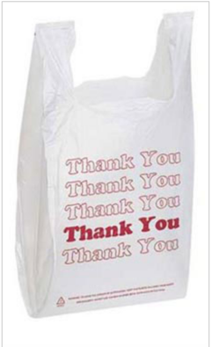

These are about 2 mils

This is .48 mils and runs about 1.5 cents each

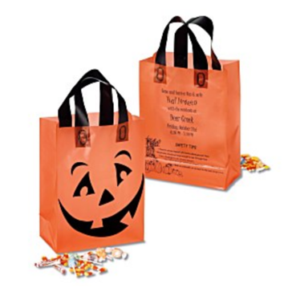
- Recyclable paper bags (must contain 40% or more recycled content with no old growth fiber) are permitted but retailers must charge .15 to the customer for each bag. They must also charge .15 for each re-usable bag (regardless of material, 2.25 mils thick or greater if plastic) they distribute. Retailers keep the fee.
These are 3 mils
- The goal is to discourage all kinds of single use bags which is why paper is charged a fee; the fee on the re-usable bag is meant to discourage people from just using endless amounts of free re-usable bags like they do plastic bags.
- Paper shopping bags run from .03 to .30 each depending on size and type
- NOTE: if retailers move towards heavier weight plastic bags to circumvent it will cost them. The bags to the left are advertised at .69 each; site has other re-usable bags priced from .29 to more than $1 each.
- NOTE: Re-usable bags can be distributed for free elsewhere; the charge is only at point of sale from the retailer/establishment. So nonprofits and others can do free re-usable bag giveaways.
- QUESTION: how does a retailer know if the bag they are purchasing uses old growth fiber? A review of bag supplier sites didn’t turn up that kind of detail

- Exempt from the bill are items that are placed in plastic before the point of sale, like stuff put in produce bags, wrapping meat/fish, bakery items, shrink wrapped food, etc.
- Bill would take effect 90 days after passage, however the state legislature has preempted bag bans until July 2020. So if the bill were to pass Council, it could not go into effect until that preemption expires.
- Enforcement is not spelled out in the bill; no fines or fees are established for violators.

