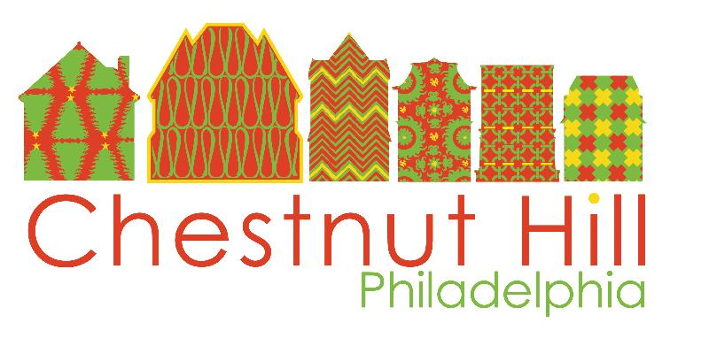
PRESS RELEASE Contact: Katie English
December 12, 2014 267-974-1250

John Story Jenks Academy for the Arts and Sciences and Chestnut Hill BID Announce New Partnership

Philadelphia, Pa – November XX, 2014. The Chestnut Hill Business District announced today that the Chestnut Hill Business Improvement District Board, Friends of J.S. Jenks and The John Story Jenks Academy for the Arts and Sciences have initiated an exciting new partnership to help the school meet some of the current challenges facing Philadelphia Public Schools.

Over the past several months, members of the BID leadership and other community business leaders have held meetings with Principal Mary Lynskey and the leadership of Friends of J.S. Jenks to determine ways to support Chestnut Hill’s local public school. Specific programmatic and capital improvement areas were identified that the School has been unable to fund with the District’s recent cuts.

Through the partnership with the BID, J.S. Jenks Academy for the Arts and Sciences, the neighborhood elementary school, will receive funding this year totaling $17,000. A portion of the funds will be used for school improvements, including repairs to the auditorium. The elementary school will also use a portion of the funding for programming to support its new focus on the arts and sciences.

“Investing in the neighborhood and our school children is vital to the future of Chestnut Hill,” said Stanley Woodward, Chairman of George Woodward Co. “The funds provided through the BID will continue to effect positive change throughout our community. We encourage and challenge our neighbors within the Chestnut Hill Community to match the BID’s contribution and support the J.S. Jenks Academy for the Arts & Sciences.”

With the recent renewal of the Chestnut Hill BID and inclusion of new residential rental properties, the BID is focusing additional efforts on initiatives that benefit all Chestnut Hill residents through a Targeted Residential Rental Fund. Jenks will submit plans to the Targeted Residential Rental Fund for utilizing the funds in the coming months. The BID’s contribution is a catalyst for the community to join this effort and support Chestnut Hill’s local public school. Private contributions to the Jenks Academy for the Arts and Sciences will benefit the school through various initiatives, including the creation of mobile classrooms, new learning tools within the classroom, field trips to local museums, scholarships for summer camp programs and access to improved technology such as new laptops.

To support the Jenks Academy for the Arts and Sciences, please contact Haviva Goldman, President of the Friends of J.S. Jenks, at info@friendsofjsjenks.org or 215-498-8593.

About the Chestnut Hill Business District
The Chestnut Hill Business Improvement District (BID) is supported by commercial property owners with a mission to keep the Chestnut Hill Business District clean, safe, and beautiful. The BID also supports marketing efforts throughout the year. The Chestnut Hill Business Association (CHBA) is a membership organization for its 125 retailers and restaurants and more than 200 professional and sustaining members. The Chestnut Hill Parking Foundation (CHPF) manages six parking lots throughout the Business District.

Chestnut Hill, located in Northwest Philadelphia and designated as Philadelphia's Garden District, was selected by Forbes.com as one of the top seven urban enclaves in the country. Chestnut Hill was voted a Distinctive Destination by the National Trust for Historic Preservation and was voted Best Main Street Shopping 2012 by Philadelphia Magazine. For more information, please visit www.chestnuthillpa.com.

About the John Story Jenks Academy for the Arts and Sciences
The John Story Jenks Academy for the Arts and Sciences is a Philadelphia School District K-8 neighborhood public school in Chestnut Hill, Philadelphia. The mission of the school is to enhance
student engagement through more in-depth avenues of study for music, art and STEM, capitalizing on
student strengths to address areas of need.The vision of the school is to provide every child with an education that will help him or her participate actively, knowledgeably, and responsibly in an increasingly complex society. For more information about the school please visit http://webgui.phila.k12.pa.us/schools/j/jsjenks or http://jsjenks.org.

About the Friends of J.S. Jenks
The Friends of J.S. Jenks (FOJSJ) is an independent, federally recognized 501c3 fundraising organization consisting of parents, teachers, administrators and community members dedicated to supporting programmatic and infrastructure development at the John Story Jenks Academy for the Arts and Sciences in Chestnut Hill, Philadelphia. For more information visit http://friendsofjsjenks.org.

# # #

