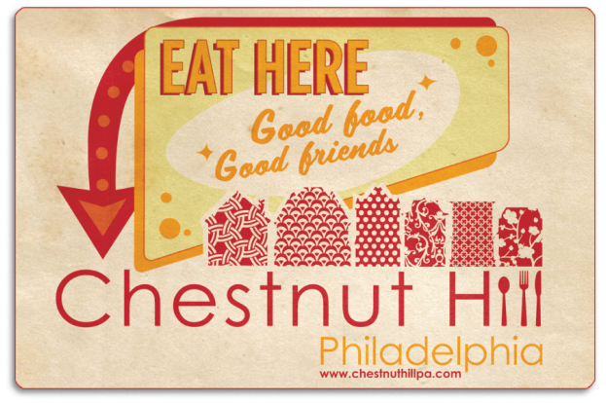

FOR IMMEDIATE RELEASE Contact: Katie English
January XX, 2015 267-974-1250

Restaurant Week in Chestnut Hill
March 1st-5th and March 8th-12th

$15 Lunch Specials and $35 Dinner Specials at your favorite restaurants in Philadelphia’s Garden District.

Philadelphia, Pa – January XX, 2015. The Chestnut Hill Business District announced today that Chestnut Hill Restaurant Week will be held March 1-5 and March 8-12, 2015. Many restaurants in Philadelphia’s Garden District will offer $15 lunch specials and $35 dinner specials Sunday through Thursday for the first two weeks in March.

“Chestnut Hill is well-known for its incredible dining options and we are delighted to announce Restaurant Week 2015,” said Martha B. Sharkey, Executive Director of the Chestnut Hill Business District. “In addition to fantastic food and beverages for the whole family, guests who dine at any of the restaurants participating in Restaurant Week can enter to win a $100 Chestnut Hill gift certificate. Two winners will be chosen the first week and two the second week.”
Participating restaurants vary from casual pub fare and family restaurants to fine dining and international cuisine. Each restaurant will be offering unique menu options. Be sure to check www.chestnuthillpa.com
for details.

Tavern on the Hill, 8636 Germantown Ave.
$15 Leprechaun Lunch: famous corned beef, cabbage and boiled potatoes served with a pint of Guinness.
$35 Dinner: Choice of soup or salad, veal parmesan over cappelini with garlic bread, homemade warm rice pudding with a glass of house wine.

Paris Bistro, 8229 Germantown Ave.
$35 Dinner Special: 3-course menu with one glass of sparkling rose.

Green Soul, 8229 Germantown Ave (at The Fareway)
$15 Lunch/Dinner Special: any signature sandwich, small soup and 8 oz. smoothie (all day)

Heirloom, 8705 Germantown Ave (Top of the Hill Plaza)
$35 Dinner Special: 3-course menu

-more-

Restaurant Week in Chestnut Hill March 1st-5th and March 8th-12th
Page 2

King’s Garden, 8223 Germantown Ave.
$35 Dinner Special: 3-course dinner for two including soup, appetizers and two entrees.

Chestnut Grill, 8229 Germantown Ave.
$15 Lunch: Bowl of soup, garden salad or small Caesar salad with any salad or sandwich.
Dinner $35 for Two: bowl of soup, garden salad or small Caesar salad (choose two) with Portobello Mushroom Ravioli, Home Style Beef Brisket, Roasted Salmon and Edamame, Tarragon Chicken Fettuccine (choose two).

Night Kitchen Bakery, 7725 Germantown Ave.
$15 Lunch for Two: share a sandwich, soup and each have a choice of a cupcake or “Best of Philly” iced brownie for dessert.

Roller’s Express-O, 8341 Germantown Ave.
$15 Late Breakfast Bonanza: eggs, bacon or sausage, short stack, potatoes, orange juice, coffee or tea from 8:30 a.m. to 2:30 p.m.

Cosimo’s Pizza, 8624 Germantown Ave.
$15 Lunch/Dinner Special: large pizza with pitcher of soda for dine-in only.

Iron Hill Brewery & Restaurant, 8400 Germantown Ave.
$15 Lunch: “Brewski and a Brew.” A Brewski Burger with lettuce, tomato, mushrooms, bacon and choice of American, sharp cheddar, or swiss with a pint of house beer.
$35 Dinner: “Taste of the Hill” includes pint of house beer and a choice of house or garden salad; fish and chips or vegetable penne or chicken pot pie; and crème brulee or Meyer Lemon pie or flourless chocolate torte.

Stella Sera Restaurant, 8630 Germantown Ave.
$35 Dinner: 4-course dinner.

Mica, 8609 Germantown Ave.
$15 Brunch: 3-course brunch from 11 a.m. to 2 p.m. on Saturday/Sunday only.
$35 Dinner: 3-course prix fixe.

El Poquito, 8201 Germantown Ave.
$35 Dinner: 3 courses including an appetizer, entrée & side, dessert.

McNally’s Tavern, 8634 Germantown Ave.
$15 Lunch: Two Schmitters and two iced teas.
$35 Dinner: Supper Special Platter (changes daily) plus a glass of wine or beer for two.

Campbell’s Place, 8337 Germantown Ave.
$15 Lunch: Soup or salad, sandwich or burger, select draft beer.
$35 Dinner: Choice of soup or salad, entrée, dessert plus a glass of red or white wine.

Restaurant Week in Chestnut Hill March 1st-5th and March 8th-12th
Page 3

Primo Hoagies, 51 Bethlehem Pike
$15 Lunch Special: 2 small sandwiches, 2 20-oz drinks; 2 small chips; and 2 cookies

*prices do not include tax or gratuity

About the Chestnut Hill Business District
The Chestnut Hill Business Association (CHBA) is a membership organization for its 125 retailers and restaurants and more than 200 professional and sustaining members. The Chestnut Hill Business Improvement District (BID) is supported by commercial property owners with a mission to keep the Chestnut Hill Business District clean, safe, and beautiful. The BID also supports marketing efforts throughout the year. The Chestnut Hill Parking Foundation (CHPF) manages six parking lots throughout the Business District.

Chestnut Hill, located in Northwest Philadelphia and designated as Philadelphia's Garden District, was selected by Forbes.com as one of the top seven urban enclaves in the country. Chestnut Hill was voted a Distinctive Destination by the National Trust for Historic Preservation and was voted Best Main Street Shopping 2012 by Philadelphia Magazine. For more information, please visit www.chestnuthillpa.com.

# # #

