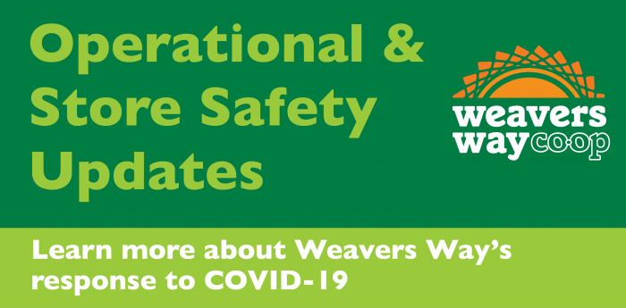
In response to the increase in COVID-19 cases in the area and concern over limiting exposure to the virus, we're taking extra precautions and measures to ensure the safety of our shoppers, members, and employees.
- Operational Changes and In-Store Safety
- Expanded Home Delivery

Operational Changes and In-Store Safety
As an essential business, Weavers Way continues to adapt to public health needs created by COVID-19 while also providing our members and customers healthy food in a safe environment. We carefully review all guidelines provided by the CDC and the Pennsylvania Department of Public Health. To that end, we are instituting the following changes, to commence Wednesday, March 18 and continue until further notice:
- Reduced store hours. All stores will be open 9 a.m.-7 p.m. daily. These adjusted hours are to allow our staff to perform deep cleaning.
- Extended senior discount to Monday through Friday. We are taking this step so we can reduce the number of customers shopping on Tuesdays, spreading shoppers out across the week. We also highly recommend our senior members take advantage of our expanded home delivery services.
- Closed self-service scoop bins in our bulk departments. We will pre-pack popular items in grab-and-go containers. Shoppers can still self-serve shop for bulk items stored in gravity bins, including coffee beans. We'll also have bulk staff available to help dispense other scooped items.
- Closed self-service soup, salad, and hot bars. Our kitchen staff will have plenty of our prepared foods available as grab-and-go. Our Cafe in Ambler is also closed.
- Automatic Extension of Cooperator Work Cycles. We understand if members would prefer not to work cooperator shifts at this time. You can request an extension from our membership department by emailing member@weaversway.coop.
For those who need to come into our store, please consider shopping during non-peak hours — early mornings and late evenings. Please keep your distance as much as possible, and please respect the social distancing needs of both our staff and customers and avoid socializing and congregating. Additionally, while many of us might prefer making multiple small shopping trips throughout the week, during the COVID-19 outbreak, making fewer, larger trips reduces everyone's exposure. We love being a social hub, but we must strive to keep everyone healthy!
To facilitate fast check out, consider loading up your EasyPay account. (Every member has one; you can access yours through the Member Center at members.weaversway.coop.) EasyPay is also the best option for delivery payment.
In all of our stores, we'll be increasing our disinfection practices. We're also encouraging employees to remain home if sickened by or exposed to COVID-19 by extending their paid leave, if needed, up to 14 days. Any guidance put forth by area health departments and the CDC will be closely followed.
For more info about our response to COVID-19 and how it might affect the Co-op, please see General Manager Jon Roesser's column in the March 2020 Shuttle.

Expanded Home Delivery
Starting Monday, March 16, Weavers Way is temporarily increasing the number of days during which home delivery is available to members who are ill, have underlying health conditions, or are otherwise at risk. We will now offer delivery daily Monday through Friday and will waive our standard delivery fee for those members.
Three types of delivery will be available:
- Standard option — We’ll deliver your groceries and bring them into your home;
- “No contact” delivery — We’ll drop off your groceries at your front door;
- Curbside pickup — We’ll assemble your order for pickup and have it waiting for you when you pull up to the store.
Orders will be fulfilled by the individual stores; minimum order is $15. Requests must be received by 5 p.m. for delivery the next day. Members can pay via check, credit card, EBT, or through EasyPay. All member discounts will apply.
Non-members and those interested in weekend deliveries should place delivery orders through Instacart. Members who are not ill or at risk but prefer to use the Weavers Way delivery service will be charged the normal delivery rate. Please email or call your individual store to arrange for delivery:
- Mt. Airy: delivery@weaversway.coop or 215-843-2350, ext. 309
- Chestnut Hill: CHdelivery@weaversway.coop or 215-866-9150, ext. 308
- Ambler: abdelivery@weaversway.coop or 215-302-5550, ext. 400
More information on our home delivery program can be found here.

